**535/1 PHYSICS**

**SECTION A**

1. C
2. C
3. A
4. C
5. C
6. C
7. B
8. B
9. B
10. D
11. C
12. A
13. C
14. C
15. B
16. C
17. A
18. D
19. A
20. B
21. D
22. D
23. B
24. D
25. A
26. A
27. D
28. D
29. D
30. B
31. D
32. B
33. C
34. D
35. C
36. C
37. D
38. A
39. C
40. C

**SECTION B**

1. (a) (i) Constant rate of change of velocity for a freely falling body

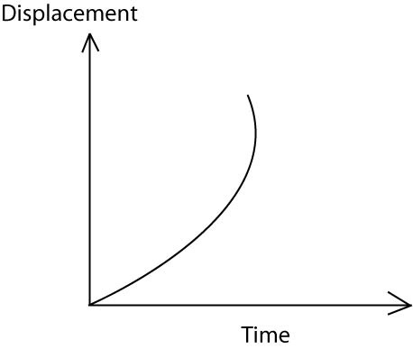(b) (ii)

(ii) S = ut + gt2

h= 0 x 4 + x 10

= 80M

1. (a) Pressure exerted by air on the earth's surface or body on earth

(b) P = H + hef

= 1- 0 x 105 + x 1.36 x 104 x 10

= 135,360Nm-2

1. (a) This is the process by which molecules move from regions of high concentration to the regions of low concentration.

(b) Total vol = 1 +99 = 100cm3 of solution

1cm3 100cm3 of the total solution of oil

0.4cm3 of total solution x 0.4 = 0.04cm3 using

V = h

40 x h = 0.004

h = 1.0 x10-4 cm

1. (a) is aware formed when the two transverse waves of same speed. Frequently wave length and amplitude travelling in opposite direction meet.

(b) Tension in the string

Length of string

Mass per unit length / thickness/diameter

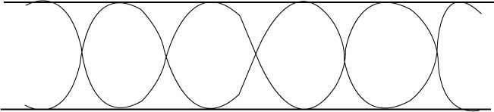(c)

6 x f = l

V = xf

330 = f x 660

f= 0.5

L = x 0.5 = 0.75m = 0.75m

1. (a) Electrical resistance is the opposition to the flow of current in the circuit

(b) Temperature

Thickness / diameter of a conductor

Length of the conductor

Nature of the wire

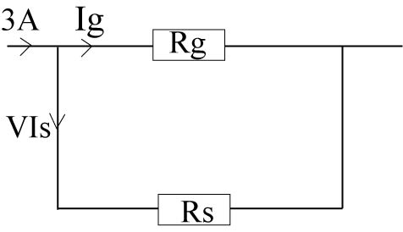(c)

Fg = f.s.d = = 0.015A

I = Is + I g

3= Is + 0.015

Is = 2.985A

Pd across Rd = pd across R2

IgRg = RsIs

Rs=

Rs = 0.0251

1. (a) Like poles repel and unlike poles attract each other

(b) Is a point in the magnetic field at which the resultant magnetic flux is zero

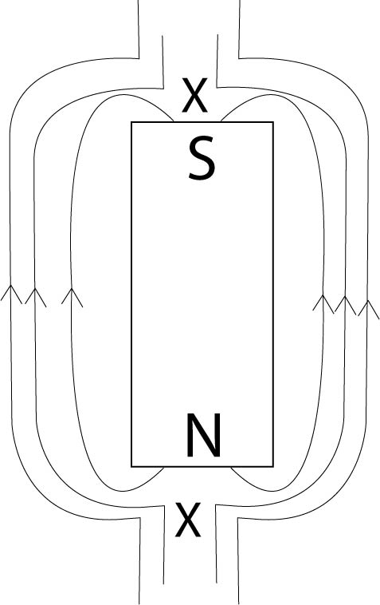(c)

1. (a) These electromagnetic waves of very short wave length produced when fast moving electrons are stopped by a hard matter.

(b) (i) A – copper anode

B – Cooling funs

(ii) A used to conduct heat away from target to the cooling fins

(c) High melting point to with stand the heat generated

1. (a) Conductors substances which has electrons that can move freely insulators –substances in which electrons do not move freely (firmly bound to nucleus)

(b) Detect presence of charge

- detect nature of charge

- Measure magnitude of charge (voltage)

- test insulating /conductivity properties of materials

C:\Users\UMTA\Desktop\ddddddd.wmf(c)

1. 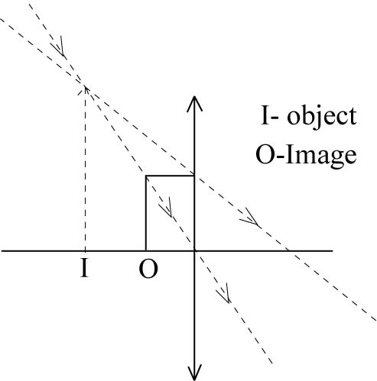(a) A point on the principal axis and parallel to the principal axis converge after refraction through the law

(b)

(c) – cameras

- correcting eye defects

- Magnifying glass

1. (a) Amount of heat required to change the kilogram (1kg) mass of substance from solid to liquid at constant temperature

(b) Pt = Ml + m CDO

1200t = x 336000 + x 4200 x (400)

= 315 seconds